Computer Language Coding Concepts

Parameters For Objects in a Diagram
This is preliminary documentation.

Default system commands can be called with an easy notation, that does not show the system command definition:

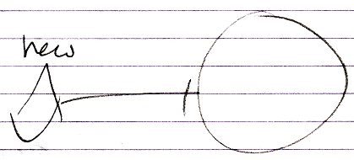

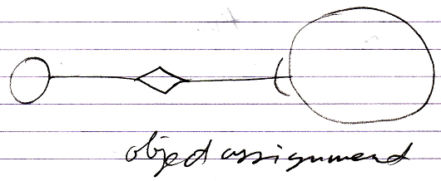

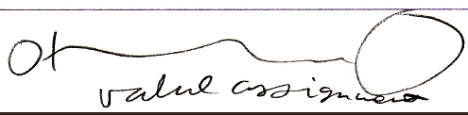

Even though you can also display the system interface and show a call to the command definition:

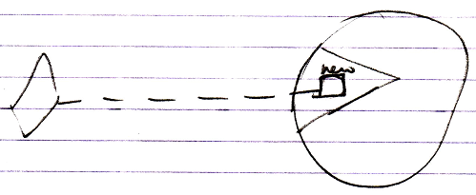

When you very much customize the system interface, you do not always have a standard notation for a consult of the system interface anymore. Giving a related object’s Object Get and Object Set a parameter, you have to display the system interface all the time.

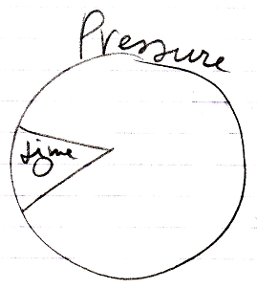

This shows, that the related Pressure object has a Time parameter.
In this case the whole system interface is extended with a parameter, because the Time parameter is not shown in a specific system command or specific system aspect, but shown inside the whole system interface. This means, that with any system command you can supply the Time parameter.

A call to the system command, such as value assignment, will show the Time parameter:

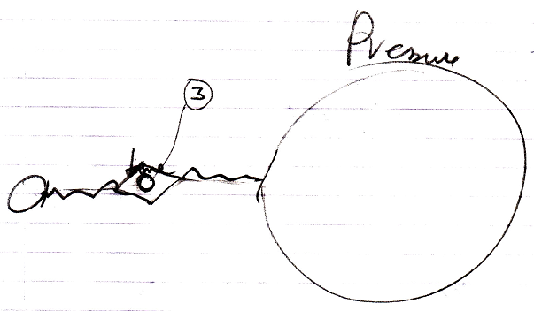

The notation above might not the best one. You may want to show the Time parameter in the related object’s system interface at all times:

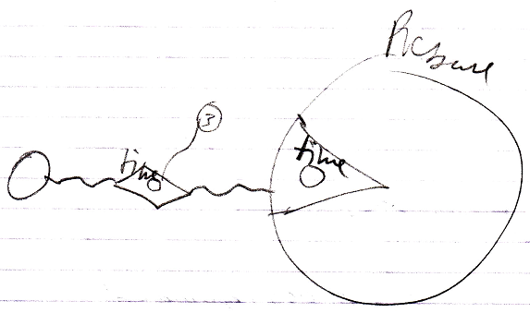

This clearly depicts, that the Pressure related object has a Time parameter. You can not go around this parameter.

See also: Parameters For Objects

Author & Copyright: Jan-Joost van Zon Date: September 30, 2008 – October 1, 2008 Location: Oosterhout, The Netherlands Status: Preliminarily finished

